TREASURY REGISTER DOCUMENT 3 OF 4 REVISION B
User interface
All five process models on one surface. Sixteen screens, navigation budget, demo run sheet.
Revision A covered counterparty control only. This revision covers the deal lifecycle, the advisory layer, currency exposure and the Oracle boundary as well, and it does so without adding a single item of navigation.
Every screen is rendered from real markup and a real stylesheet, at real dimensions, with the seeded figures from document 1. Nothing here is a sketch.
Companion documents: 1, data model. 2, application programming interface. 4, architecture.

1. Principles
Principle | What it means, and why
One surface carries all five models | The process design draws five models because they are five different subjects, not because they are five different systems. They share one database and one deal record, so they share one screen. Counterparty control is the book. The deal lifecycle is the blotter and what opens from it. The advisory layer is a proposal that lands in the same ticket. Currency exposure is a second tab in the exposure panel. The Oracle boundary is a set of labels on the timeline.
Navigation is a budget, not a feature | Every item of navigation costs the user a decision and costs a demonstration its momentum. Section 2 sets a hard budget and section 12 shows the whole five minute run inside it.
The gate is the loud element | One thing on the page is allowed to be visually strong: the six checks, changing state as the user types. Everything around it stays quiet, because a page where several things compete has nothing to look at.
State the arithmetic, not the verdict | Group limit exceeded tells a user nothing. Northern Group would reach £28,119,836 against a group limit of £25,000,000 tells them what to do next.
Show how a figure was measured | The blotter shows the measurement basis next to the principal, so a forward is never read as its notional.
A refusal offers a route forward | A blocked deal shows either the amount that would fit or the reason nothing would.
The model proposes, it never decides | A recommendation arrives pre filled in the ordinary ticket and runs the ordinary six checks. Nothing is recorded because a model suggested it, and the interface makes that visible rather than asserting it.

2. Navigation budget
These are limits, not aspirations. Any change that breaks one of them is a change to argue about rather than absorb.
Rule | Limit | Why
Surfaces | One | The loop is one circuit. Splitting it makes the viewer reassemble it mentally.
Page loads after the first | Zero | Everything is a panel over the surface or a state change on it.
Depth from the surface to anything | One click | Nothing is two levels down. The deal lifecycle, the advisory run, currency exposure and the evidence behind a booking are each one click.
Panels open at once | One | Opening a panel closes any other. Panels never stack, so there is never a back button.
Items in the strip | Five | Adding a sixth means merging two. This is why the exception queue and confirmation mismatches share one entry rather than having one each.
Confirmation dialogs | Zero | The only extra input before a write is the override reason, and it appears inline in the ticket rather than in a dialog.
Typing needed in the demonstration | Two amounts | Everything else is a click. Section 12 lists the run.
Fields on the ticket | Five | Counterparty, instrument, principal, term, rate. Nothing else is needed to test a deal.
The budget is what makes the extra scope affordable. Revision A had five strip items and one panel per deal. Revision B adds the whole transaction lifecycle, the advisory harness and currency exposure, and still has five strip items, because each new thing attached to something already on screen instead of sitting beside it.

2.1 Where the new scope attached
New scope | Attached to | Navigation added
Deal lifecycle, capture to close | The blotter row, which already existed. A stage column replaces the status column, and clicking the row opens the timeline. | None
Confirmation matching and mismatches | The existing queue, with a reason code. The strip entry is renamed from Exceptions to Queue. | None
Advisory recommendation | The deal ticket, as a card above the fields. Accepting fills the ticket. | None
The advisory run in full | A strip entry, replacing Sent to Oracle, which moved onto the deal timeline where it belongs. | None, net
Currency exposure and hedge linkage | A second tab inside the exposure panel. | None
The Oracle boundary | Labels on the deal timeline: instructed, paid, journals posted, reversals. | None

3. Process model coverage
Every step of every model, and where it appears. A step marked outside is performed by a bank, a broker or a rating agency and is shown as a labelled event rather than as something a user does. A step marked Oracle is performed by Fusion or EPM and appears as a labelled event for the same reason.

3.1 Model 1, counterparty control
Step | Where in the interface | Cost
1 Raise request | Add a counterparty panel, step 1 | 1 click
2 Create draft | Same panel, on save. Status moves to draft | in panel
3 Verify and rate | Same panel, step 2. Identifier, group parent, rating, instruments | in panel
4 Set limit, term | Same panel, step 3. Proposed from the rating band | in panel
5 Approve | Same panel, step 3. The approver field is required | in panel
6 Activate | Same panel, step 4. The name appears in the book and the ticket | in panel
7 Propose deal | The ticket, on the surface | on the surface
8 Six checks | The check panel, live on every keystroke | on the surface
9 Exception queue | Queue panel, with the resize, override and cancel controls | 1 click
10 Record deal | The action on the ticket. The book and blotter move | on the surface
11 Execute and post | Deal timeline: payment instructed, paid, journals posted | 1 click
12 Rating action | Ratings and policy panel | 1 click
13 Re-test book | Runs on apply. No screen of its own | automatic
14 Flag breach | Breach count in the strip turns red, the book row tints, the blotter row carries a breach pill | on the surface
15 Respond | Breaches panel, four responses | 1 click
16 Revise limits | The book, immediately. Limit and term columns change, and the history is in the counterparty panel | on the surface
Exposure view | Exposure panel, counterparty tab | 1 click

3.2 Model 2, deal lifecycle
Step | Where in the interface | Cost
1 Execute deal | Deal timeline, first event, labelled outside | 1 click
2 Capture deal | The ticket, or auto created from the confirmation | on the surface
3 Confirmation in | Deal timeline, labelled outside. Blotter stage reads awaiting confirmation until it lands | on the surface
4 Match | Blotter stage reads matched. The timeline names what agreed | on the surface
5 Exception | Queue panel, reason code mismatch. Correct, challenge or cancel | 1 click
6 Approve | The ticket on booking, and the timeline afterwards | on the surface
7 Instruct payment | Deal timeline, labelled Oracle | 1 click
8 Payment run | Deal timeline, labelled Oracle | 1 click
9 Daily accrual | Blotter stage shows the daily figure. The timeline shows the total recognised | on the surface
10 Journal built | Deal timeline, with the account it was coded to | 1 click
11 Posted to GL | Deal timeline, labelled Oracle | 1 click
12 Amendment raised | Deal timeline, marked as the event that changes everything after it | 1 click
13 Recalculate | Deal timeline, with the corrected figures | 1 click
14 Reverse, repost | Deal timeline, naming the amount and the closed periods it comes out of | 1 click
15 Reversals to GL | Deal timeline, labelled Oracle | 1 click
16 Maturity due | Blotter stage reads matures in n days. The timeline shows the expected amount | on the surface
17 Bank pays | Deal timeline, labelled outside | 1 click
18 Three way match | Deal timeline. Deal, confirmation and statement | 1 click
19 Close deal | Deal timeline, final event. Headroom returns to the book | 1 click
Exposure held | The used column of the book, and the measured column of the blotter | on the surface
Nineteen steps, one panel, one click. The timeline is the whole of model 2 in a single view, which is the only way to carry that much lifecycle without spending navigation on it.

3.3 Model 3, the advisory harness
Stage | Where in the interface | Cost
1 Assemble context | Advisory panel, stage 1. Names the four inputs | 1 click
2 Detect the gap | The advisory card on the ticket states the gap in one line | on the surface
3 Build candidates | Advisory panel, stage 3. All four candidates priced, with the excluded one and why | 1 click
4 Rank and explain | The reasoning on the advisory card, and stage 4 of the panel | on the surface
5 Validate | Advisory panel, stage 5. Three tests, each shown as passed | 1 click
5b Rule based pick | Shown in place of the reasoning, flagged, when validation fails | on the surface
6 Accept or edit | Accept and load the ticket, or Reject. Editing is simply typing over the loaded values | on the surface
Then the six checks | The ordinary check panel, on the ordinary ticket | on the surface

3.4 Model 4, currency exposure and hedging
Step | Where in the interface | Cost
1 Exposure arises | Outside. Appears as a row when captured | n/a
2 Capture exposure | Exposure panel, currency tab. Currency, amount, expected date, source | 1 click
3 Net by currency | Currency tab, netted by time bucket | 1 click
4 Test coverage | Currency tab, covered against the policy target per bucket | 1 click
5 Gap flagged | Currency tab, stated with the amount and the date it falls due | 1 click
6 Recommend cover | The advisory card on the ticket, the same mechanism as a cash surplus | on the surface
7 Accept or override | Accept and load the ticket | on the surface
8 Becomes a deal | An ordinary FX forward through the ordinary ticket and the ordinary six checks | on the surface
9 Link to exposure | Currency tab, shown indented under the exposure it covers | 1 click
10 to 12 Underlying moves, coverage drifts, roll or close | Currency tab, as a coverage warning with the decision recorded | 1 click
13, 14 Payment made, both close | Deal timeline for the hedge, currency tab for the exposure | 1 click
The currency tab carries a permanent statement that counterparty exposure and currency exposure are separate figures moving in opposite directions and are never netted. That warning is in the interface rather than only in the documentation, because the interface is where somebody would try it.

3.5 Model 5, the Oracle boundary
Interface | Where it surfaces | Cost
I-1 deal details in | The ticket, or auto capture | on the surface
I-2 master data, rates | Not visible. Reference data behind the forms | none
I-3 balances in | The uninvested cash figure under the book, and the concentration check workings | on the surface
I-4 payment request out | Deal timeline, payment instructed | 1 click
I-5 expected leg out | Deal timeline, alongside the instruction | 1 click
I-6 journals out | Deal timeline, journals posted and reversals to GL | 1 click
I-7 future cash flows out | Not visible. It is what stops the advisory layer recommending cover twice | none
I-9 forecast in | The advisory card and stage 1 of the advisory panel | on the surface
I-10 entity and group parent in | The identifier and group fields in the add a counterparty panel | in panel
I-11 ratings in | The ratings and policy panel. Operator entered in this build | 1 click
I-12 confirmations in | Deal timeline, confirmation received. Kept separate from I-1 on purpose | 1 click
Two interfaces are deliberately invisible. Reference data and the nightly cash flow feed have no screen because nobody acts on them. Everything a person needs to see about the Oracle boundary is on the deal timeline, where it is attached to the deal it concerns rather than sitting in an integration log.

4. Anatomy of the surface
1440 x 900

+--------------------------------------------------------------------+
| header 56px brand + badge today | enforcement | reset |
+-----------------------------------------+--------------------------+
| book 58% | ticket 42% |
| | |
| Approved counterparties [Add] | Propose a deal |
| +-----------------------------------+ | +---------------------+ |
| | name | rating | limit | used | .. | | | advisory card | |
| +-----------------------------------+ | +---------------------+ |
| summary line | counterparty |
| | instrument |
| Blotter | principal | term |
| +-----------------------------------+ | rate |
| | cp | instr | principal | stage | | +---------------------+ |
| +-----------------------------------+ | | six checks | |
| clicking a row opens the | +---------------------+ |
| whole deal lifecycle | verdict + approver |
| | [ Record deal ] |
+-----------------------------------------+--------------------------+
| strip Exposure | Queue (n) | Breaches (n) | Advisory (n) | Ratings |
+--------------------------------------------------------------------+

Region | Contents | Carries
Header | Brand, prototype badge, the editable date, the enforcement setting, reset | The two unsettled design decisions, made visible
Book | Counterparty, group and group utilisation, rating, limit, used, headroom, term | Model 1, the state of the world
Blotter | Counterparty, instrument, principal, measured exposure, lifecycle stage, flag | Model 2, at a glance. Each row opens its own timeline
Ticket | The advisory card when there is a recommendation, then five fields | Model 3 stage 6, and model 1 step 7
Check panel | Six rows, live | Model 1 step 8, the gate every model passes through
Strip | Exposure, Queue, Breaches, Advisory, Ratings and policy | Five entries, capped
Panel | 660 px over the surface, one at a time | Everything else

5. Screens

5.1 The surface, all checks passing
Three things a reader should take from this screen without being told. Exposure is computed rather than typed, which the summary line says outright. Each counterparty row carries its group utilisation underneath the name, so a name that looks free at entity level can still be visibly constrained by its group. And the verdict names who has to sign before the user commits, not after.
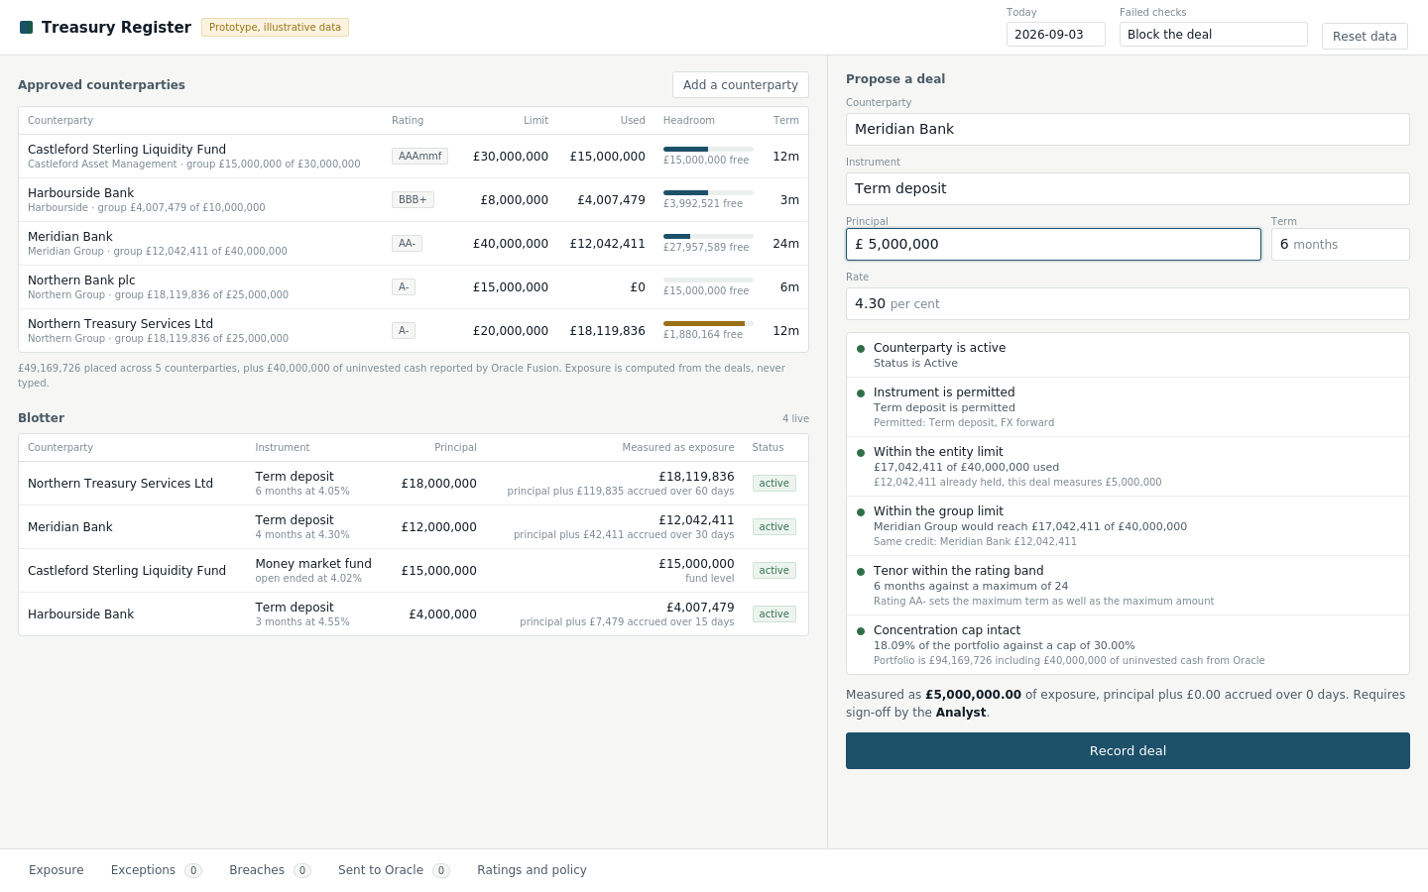
Screen 1. Five counterparties, four live deals, a £5,000,000 six month deposit proposed with Meridian Bank.

5.2 A failed group check
The entity limit passes with room to spare, because Northern Bank plc holds nothing. The group check fails, because Northern Treasury Services Ltd is the same credit and already holds £18,119,836. Nothing else on the screen connects those two names. Check 4 is the only thing that does.
The failed row carries the arithmetic, the other holdings in the group named individually, and a control that resizes the ticket to the largest amount that would pass.
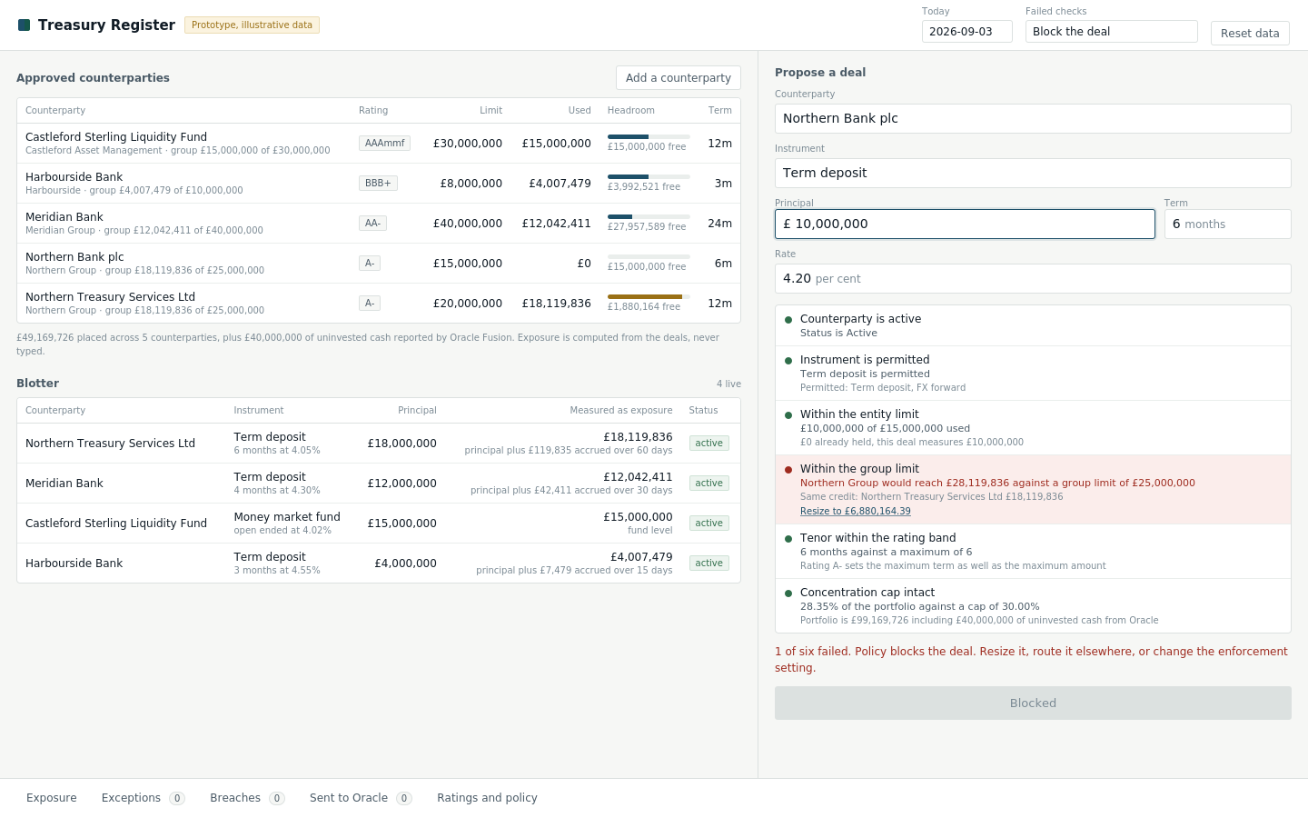
Screen 2. £10,000,000 with Northern Bank plc. Five green, one red.

5.3 The same deal under a warning policy
The same six results, a different consequence. A reason field appears, the action changes from Blocked to Override and record, and the reason is required rather than optional. Switching this setting live is the fastest way to settle which policy the business wants.
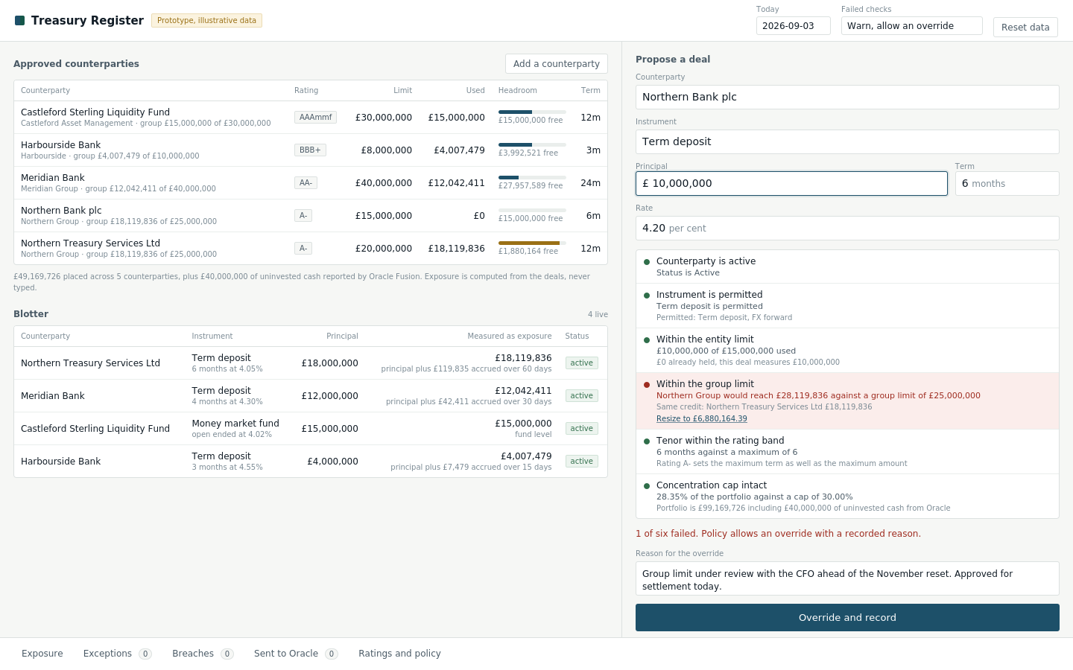
Screen 3. Enforcement switched to warn with an override.

5.4 After a downgrade
The rating pill reads BBB plus and watch. The limit has dropped from £15,000,000 to £8,000,000 and the term from six months to three. The row is tinted, the breach count has turned red, and the blotter row carries a breach pill.
The deal recorded at £6,880,164 is still inside the new £8,000,000 amount. It is the permitted term that broke. Amount and duration are two independent constraints, and this screen is where that becomes obvious rather than being asserted.
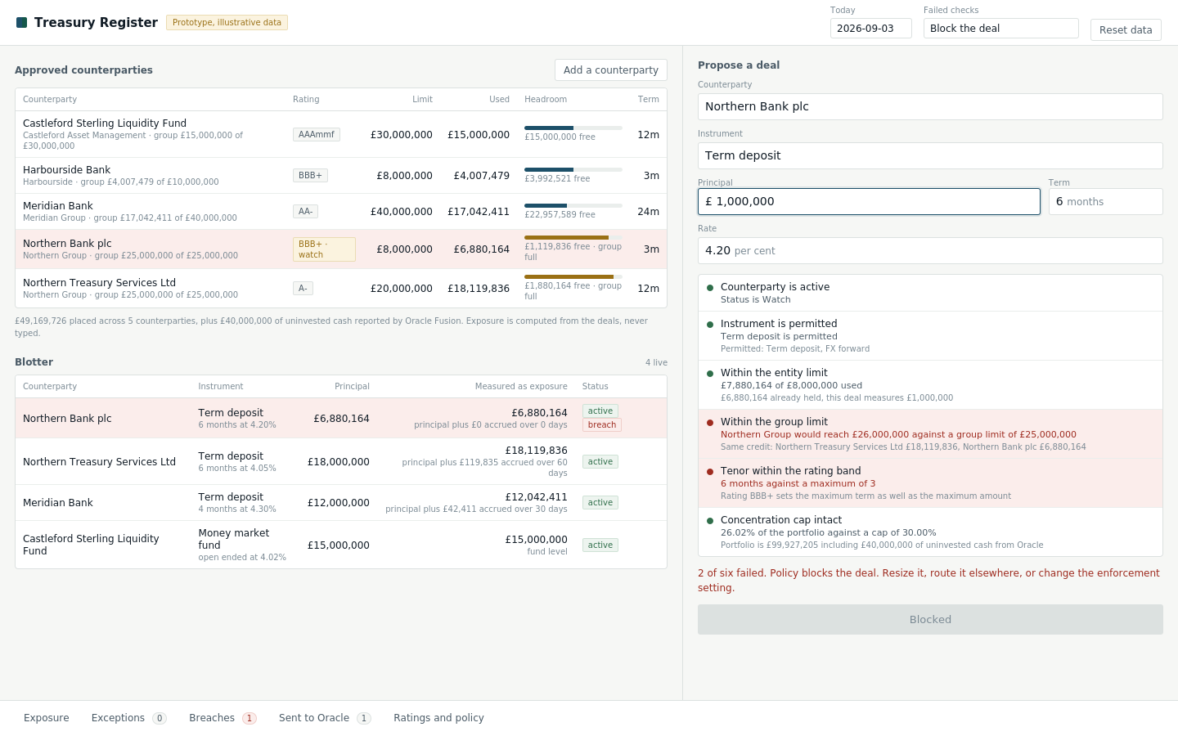
Screen 4. Northern Bank plc moved to BBB+. The book has been re-tested.

5.5 A recommendation from the advisory layer
The overnight run found £8,000,000 landing uninvested and an empty bucket in the maturity ladder. The card states the gap, the recommendation, the reasoning, and what was not picked and why. Accepting it fills the ordinary ticket.
The six checks then run exactly as they would on a deal somebody typed, and the verdict says so. This is the whole argument about the advisory layer made in one line of interface copy rather than in a paragraph of reassurance.
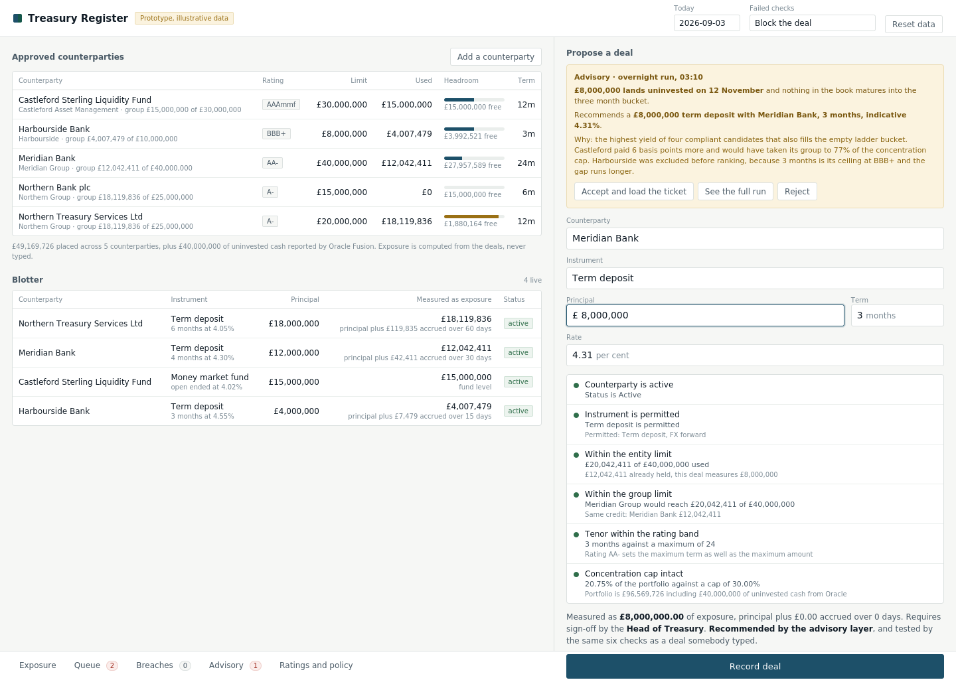
Screen 5. The model proposes. The policy engine disposes.

5.6 The blotter carrying the deal lifecycle
The status column becomes a stage column. Each row shows how far through its lifecycle a deal has travelled, and the two that need attention say so: one is awaiting confirmation, one has a confirmation mismatch, two are accruing with the daily figure shown, and one has been amended and is approaching maturity.
Nothing here is a new screen. It is the same blotter with one column replaced, and clicking any row opens the full timeline for that deal.
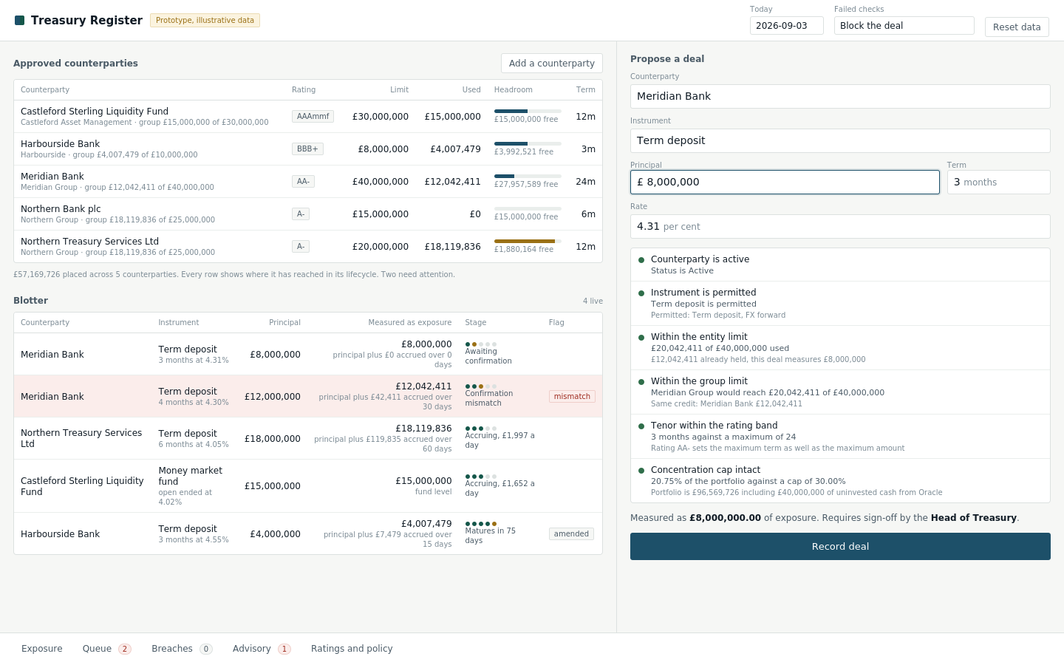
Screen 6. Model 2 at a glance, on the surface.

6. Panels
Seven panels, each one click from the surface, each opening over it. Shown at their own width so the content is legible.

6.1 The deal lifecycle
Nineteen steps of model 2 in one view. Execution and confirmation are labelled as outside, payment and journals as Oracle, so the boundary is visible without a separate integration screen. The amendment is marked as the event that changes everything after it, and the three future events are shown greyed rather than hidden.
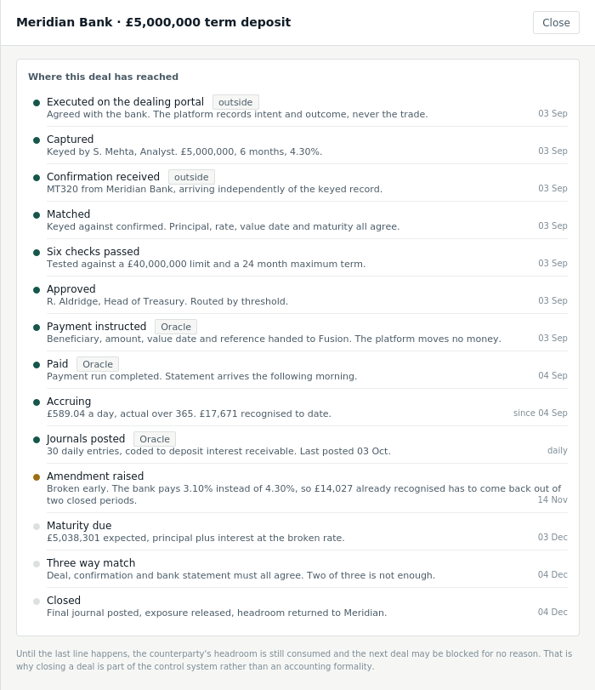
Reached by clicking any blotter row.
The closing line is the point. Until a deal closes, the counterparty's headroom is still consumed and the next deal may be blocked for no reason. That is why closing is part of the control system rather than an accounting formality.

6.2 The advisory run
Six stages, one of which calls a model, and the four failures it structurally cannot produce. The candidate list is shown priced and complete, including the one excluded before ranking and the reason, because the exclusion is the guardrail rather than the ranking.
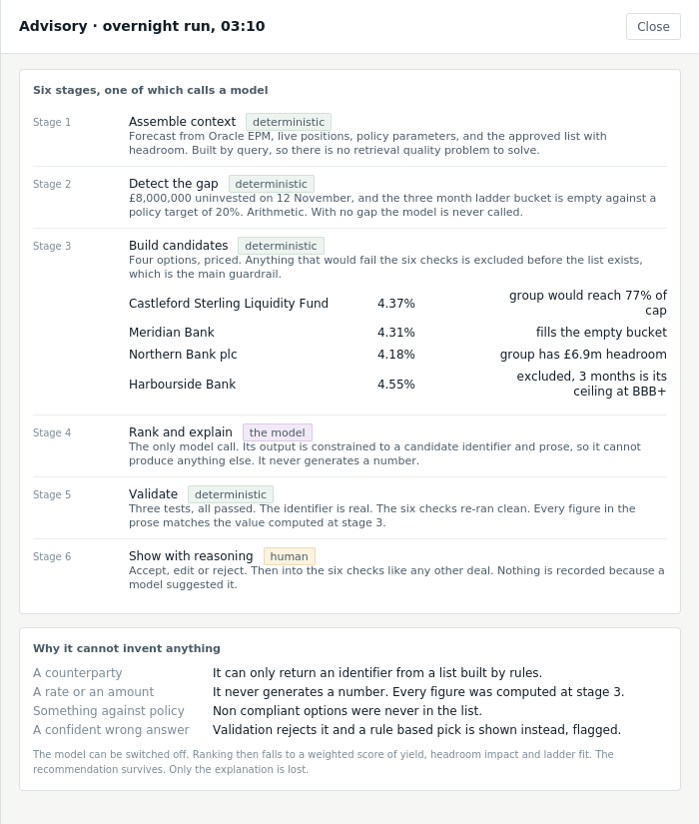
Reached from the strip, or from See the full run on the advisory card.

6.3 Currency exposure
A second tab inside the exposure panel. Euro obligations netted by time bucket, coverage against the policy target, and each hedge shown indented under the exposure it covers. Without that link you own forwards and cannot say anything is covered.
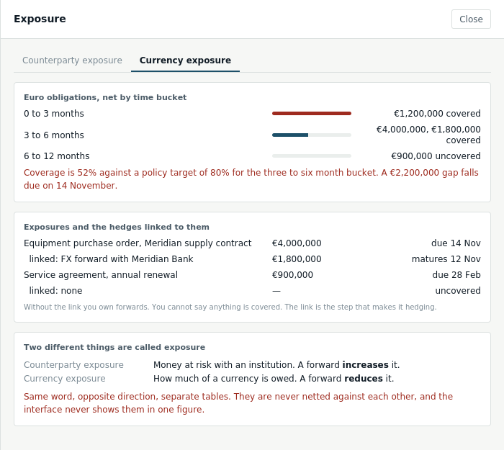
The exposure panel, currency tab.

6.4 The queue
One queue, two causes, distinguished by a reason code and by a label. A limit failure happens before the deal exists and is resolved by changing the deal. A confirmation mismatch happens after it exists and is resolved by agreeing what was actually traded.
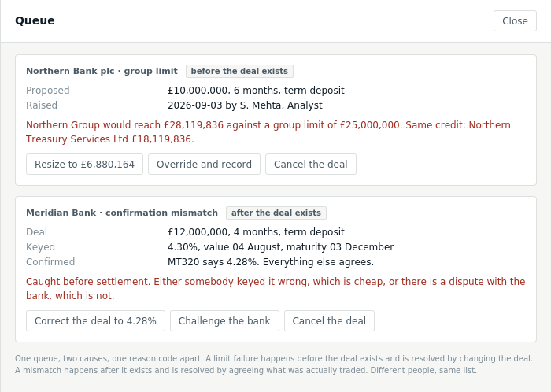
One strip entry rather than two, which is what keeps the budget.

6.5 Exposure, breaches, evidence, onboarding, ratings
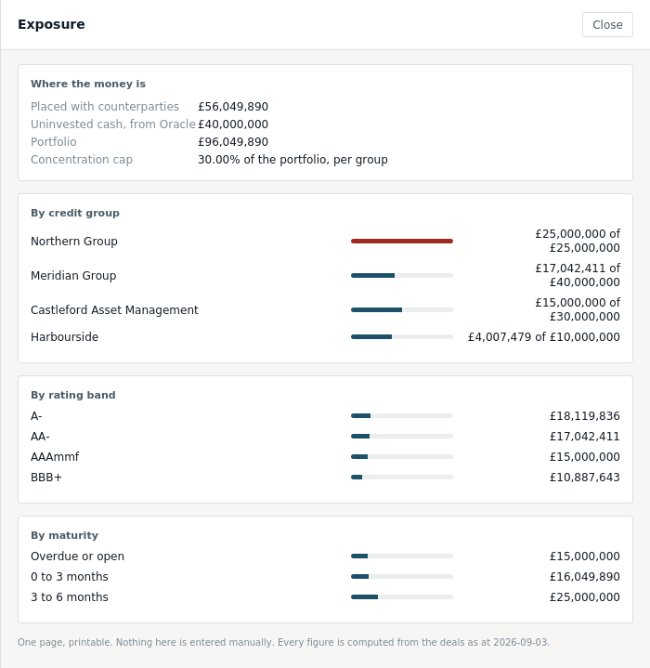
Exposure, counterparty tab. Utilisation by group, band and maturity.
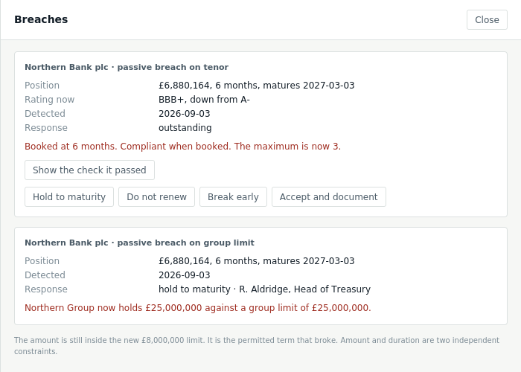
Breaches. Four responses, and a control that opens the check the position passed.
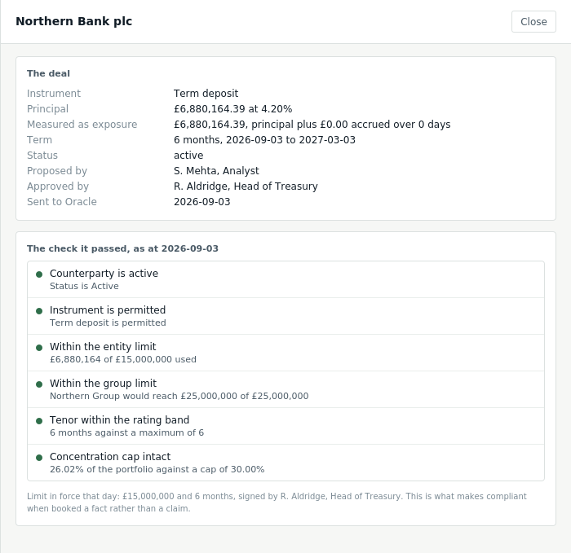
The evidence behind a deal. What turns compliant when booked into a fact.
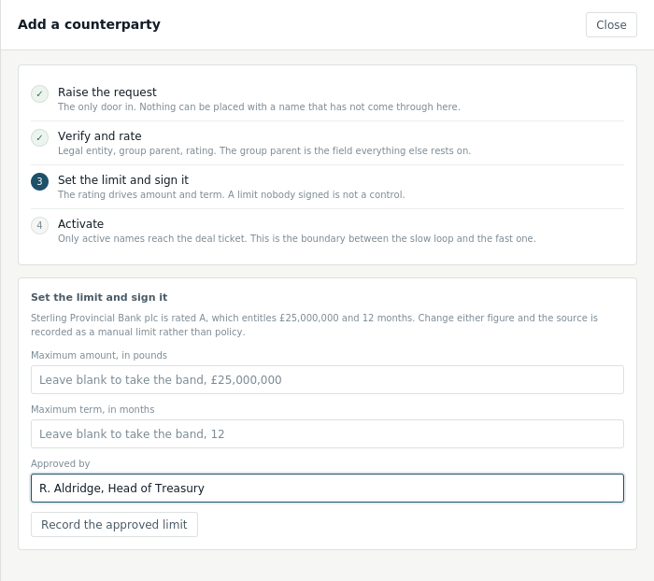
Add a counterparty. Four steps, each separately refusable.
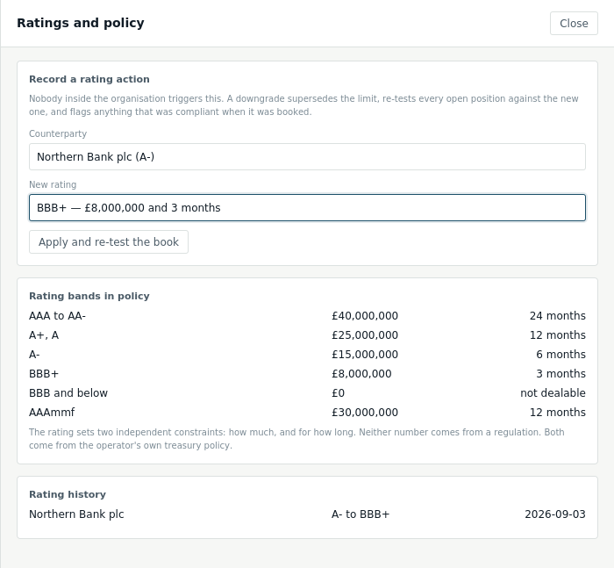
Ratings and policy. Kept behind the strip, because a prominent downgrade control makes a demonstration look staged.

7. Components

Book row
Element | Specification
Name | Display name at 12 px, weight 500. Group name and group utilisation underneath at 10 px, muted.
Rating | A pill. Adds a watch suffix and the amber palette when the status is watch.
Headroom | A 5 px bar with a label. Navy below 85 per cent, amber from 85, red at 100. The label adds group full at the group ceiling.
Row state | Tinted when the counterparty carries an outstanding breach. Clicking loads that counterparty into the ticket.

Blotter row
Element | Specification
Measured column | The exposure figure with the measurement basis underneath, so a forward is never read as its notional.
Stage | Five dots and a label. Filled for stages passed, amber for the stage in progress. Labels: awaiting confirmation, matched, accruing with the daily figure, matures in n days, closed.
Flag | A pill only when something needs attention: mismatch, breach, amended. No pill on a healthy row, so a flag means something.
Click | Opens the deal lifecycle panel. The whole of model 2 is one click from here and nowhere else.

Advisory card
Element | Specification
Position | Above the ticket fields, inside the ticket column. Not a banner across the page and not a notification, because it is an input to the work rather than an interruption of it.
Content | The run time, the gap in one sentence, the recommendation in one sentence, the reasoning, and what was not picked with the reason.
Actions | Accept and load the ticket, See the full run, Reject. Accepting fills the fields and triggers a check immediately.
After accepting | The card collapses to one line in the verdict: recommended by the advisory layer, and tested by the same six checks as a deal somebody typed.
When validation failed | The reasoning is replaced by the rule based pick, flagged as such. The recommendation survives, only the explanation is lost.

Timeline, tabs, and the rest
Component | Specification
Timeline event | A dot, a title, one line of detail, and the date right aligned. Green for done, amber for an amendment, grey for future. Source tags for outside and Oracle.
Tabs | Only inside the exposure panel, and only two. Counterparty exposure and currency exposure never appear in one view, because they must never be netted.
Verdict | On a pass: the measured exposure, how it was measured, the approver required. On a failure: how many failed and what the policy allows.
Panel | 660 px, or 92 per cent on a narrow screen. Closes on the control, the scrim and escape. Opening one closes any other.
Count badge | Neutral at zero, red above. Queue, breaches and advisory only.
Toast | Bottom centre, 2.6 seconds. Confirmations and errors that do not belong to a field.

8. Interaction

8.1 The live check panel
Behaviour | Specification
Trigger | Any change to any of the five ticket fields, including a change made by accepting a recommendation.
Debounce | 150 milliseconds. A pause in typing produces one call.
Cancellation | Every call carries an AbortController and cancels the one before it. Without it a slow response can arrive after a newer one and paint a verdict for an amount the user has already changed. That is a wrong answer, not a slow one.
While in flight | The previous result stays. Clearing it produces a flicker on every keystroke and tells the user nothing.
Accepting a recommendation | Fills the fields and checks immediately rather than waiting out the debounce.
Resize | Sets the principal to the returned figure and checks immediately.

8.2 Writes
Action | Behaviour
Record deal | Posts the ticket. The server re-runs the checks. The client never sends its own result. On a pass the deal is recorded and approved in the same interaction and a toast names the role that signed.
On a block | A toast says the deal was blocked and went to the queue. The queue count turns red. The ticket keeps its values, because the user will usually resize rather than start again.
Resolve a mismatch | Correcting the deal reruns the six checks, because a corrected rate changes the accrual and can change the measured exposure. Challenging leaves the deal in place and the item open.
Respond to a breach | Records the decision. Does not clear the breach and does not change the deal. The position is still outside policy.
Apply a rating action | Closes the panel, reloads the state, and opens the breaches panel when the re-test created any. This is the one place the interface navigates on the user's behalf, because the result is the reason they pressed it.

8.3 Keyboard and focus
Concern | Specification
Tab order | Header, ticket fields, action, strip. The book and blotter come after the ticket, because the ticket is where the work happens.
Focus ring | Two pixel navy outline, two pixel offset, on every focusable element. Never removed.
Escape | Closes the open panel.
Enter in the ticket | Does not submit. Recording a deal is deliberate and the panel is changing under the user as they type.
Reduced motion | Respected. Nothing in the interface depends on motion to be understood.

9. States
State | Where | Treatment
First load | Whole surface | One state call returns everything, so one load rather than a waterfall. A single quiet skeleton, not eleven spinners.
No checks yet | Check panel | Six rows with grey dots and no detail. The panel is never absent, so its position never shifts.
No recommendation | Ticket | The advisory card is absent and the fields sit at the top. No empty card, because an empty card implies something is broken.
Empty queue | Panel | Nothing open. A blocked deal or a confirmation mismatch lands here with a reason code.
Empty breaches | Panel | Nothing flagged. A breach appears when a rating action makes an existing position fall outside a revised limit.
No currency exposure | Exposure, currency tab | No euro obligations recorded. The tab stays visible, because its absence would hide the distinction it exists to make.
No limit in force | Book row | An em dash, and no limit in force in the headroom label. Not zero, because zero is a limit and this is the absence of one.
Refused write | Toast or field | Field failures attach to the field using the field key from the error body. Everything else goes to the toast.

10. Design tokens

10.1 Colour
Token | Value | Used for
paper | #F6F7F5 | Page background.
card | #FFFFFF | Every surface that holds data.
ink | #111C26 | Primary text.
ink-70 | #4A5A66 | Secondary text and check detail.
ink-45 | #7B8A94 | Labels, workings, muted figures.
rule | #DCE1E0 | Borders.
rule-soft | #EAEEEC | Row separators.
counterparty | #1D5069 | Counterparty control. Primary action, headroom bar, focus ring.
deal | #15574A | The deal side. Timeline events, completed stages.
gate | #9A7015 | The gate and anything unsettled. Prototype badge, watch state, the advisory card, a bar above 85 per cent.
model | #5B3B77 | The single model call, and nothing else. One colour used once.
breach | #9E2B1F | Failures, mismatches and breaches.
ok | #2F6E4A | Passes and active states.
The subject colours are the same three used in the process design and the data model diagrams. Blue is counterparty control, green is the deal lifecycle, amber is where they meet and something is decided. Purple is added here for one purpose: it marks the single stage that calls a model, so a reader can see at a glance how little of the advisory harness is not deterministic.

10.2 Type and spacing
Token | Value | Used for
Family | Inter, falling back to the system sans stack | One family. No display face, because nothing here is a headline.
Figures | Tabular numerals wherever a number appears | Columns of money must align. Not a preference in a treasury system.
15 px / 600 | Product name
14 px | Ticket field values | The largest thing the user types into.
12 px | Table content and body
11.5 px / 500 | Check name, timeline event title
10.5 px | Check detail, timeline detail
10 px | Labels, workings, stage labels, sub lines
Spacing | A 4 px base. 7 to 9 px inside table cells, 13 px inside cards, 16 to 18 px at region edges
Radius | 3 px on controls, 4 px on containers, 2 px on pills and tags | Small and consistent.

11. Interface copy
Rule | Written | Not written
State the arithmetic | Northern Group would reach £28,119,836 against a group limit of £25,000,000 | Group limit exceeded
Name the group, not just the counterparty | Same credit: Northern Treasury Services Ltd £18,119,836 | Group aggregation failure
Say how a figure was measured | principal plus £119,835 accrued over 60 days | £18,119,836
Distinguish a passive breach | Booked at 6 months. Compliant when booked. The maximum is now 3. | Tenor breach
Say what the model did and did not do | Recommended by the advisory layer, and tested by the same six checks as a deal somebody typed | AI powered recommendation
Give the reason for an exclusion | Excluded before ranking, because 3 months is its ceiling at BBB+ and the gap runs longer | Not eligible
An empty view invites an action | Nothing open. A blocked deal or a confirmation mismatch lands here with a reason code. | No records found
A refusal says what to do | A limit nobody signed is not a control. Record the approver. | approved_by is required
The action names what happens | Record deal, then Recorded. Override and record, then Overridden, with the reason recorded. | Submit, then Success

12. Demonstration run sheet
Five minutes, fourteen clicks, two amounts typed, no page loads. Every model appears. Timings are the point at which to move on, not a target to hit.
At | Do | Cost | The line
0:00 | Open the page. Say nothing for a beat. | 0 | Five counterparties, four live deals. Every figure computed from the deals, none of it typed.
0:20 | Read the advisory card. | 0 | The overnight run found eight million landing uninvested and an empty bucket in the ladder. It recommends one deal and says why, and it names what it did not pick and why not.
0:50 | Accept and load the ticket. | 1 | Now watch what happens to a recommendation. It goes through the same six checks as anything a person typed.
1:05 | Record deal. | 1 | Routed to the Head of Treasury by threshold, signed, on the book.
1:25 | Type 10,000,000, choose Northern Bank plc. | 2 fields | Five green, one red. Nothing on this screen said these two names were the same credit. Check four is the only thing that did.
2:00 | Press Resize to £6,880,164. | 1 | Green while you watch. The group lands at exactly its limit.
2:10 | Record deal. | 1 | Booked.
2:25 | Click that row in the blotter. | 1 | This is the whole transaction lifecycle. Execution, confirmation arriving separately, matching, approval, the payment instruction to Oracle, daily accrual, journals, the amendment that has to come back out of two closed periods, and the three way match at maturity. One click, one panel.
3:10 | Close. | 1
3:15 | Ratings and policy, Northern Bank plc, BBB+, apply. | 3 | Nobody inside triggers this. The limit drops, the book is re-tested, and something that was compliant when it was booked is now not.
3:50 | Read the breach. | 0 | The amount is still inside the new limit. It is the term that broke. Amount and duration are two independent constraints.
4:05 | Show the check it passed. | 1 | The six checks as they stood on the day, the limit in force, and the name that signed it. Compliant when booked as a fact rather than a claim.
4:30 | Exposure, then the currency tab. | 2 | The second thing called exposure. A forward increases the first and reduces the second. They are never netted, and the screen says so.
5:00 | Stop.
Two moments to rehearse. The resize at 2:00, because the figure is not round and a viewer will notice. And the breach at 3:50, because the instinct is to say the deal is too big when it is not.

13. Build notes
Concern | Decision
Framework | Next.js App Router, client components throughout. Every screen here is interactive and none benefits from server rendering.
No rules in the client | The client formats, lays out and debounces. It does not decide. No check logic, no limit arithmetic, no approval threshold and no candidate filtering in the front end. Any pull to put one there is a design failure to raise rather than accommodate.
State | One state object from the state call, replaced wholesale after every write. No optimistic updates. The book, the blotter and the exposure panel must agree, and refetching is the cheapest way to guarantee it.
Panels | One component per panel body, one shared shell. The shell owns the scrim, escape, focus return and the rule that opening one closes another.
The timeline | Rendered from the deal record plus its events. Future steps are computed from the maturity date rather than stored, so a deal that has not matured still shows what will happen.
Formatting | One module. Pence to pounds, basis points to per cent, dates, and the stage label. Nothing formats inline.
Components | Header, Book, Blotter, Ticket, AdvisoryCard, CheckPanel, Verdict, PanelShell, and one body per panel. Around eighteen files.
Styling | Plain CSS with the section 10 tokens as custom properties. No utility framework.

13.1 What the interface does not do yet
Absent | Consequence | When it matters
Sign in | No user. Actors are typed names, and the approval router names a role nobody is checked against. | Before anyone outside the room uses it.
Editing an amendment | The timeline shows amendments. It cannot raise one. | Phase three, with reversals.
Capturing a currency exposure | The currency tab reads. It cannot create. | When the FX register is real rather than illustrative.
Sorting and filtering | Five counterparties and a handful of deals fit on screen. | At about twenty counterparties.
Notifications | A rating action is only seen by whoever is looking. | When the ratings feed arrives without a person pressing anything.
Printing | The exposure panel is designed to be printable and has no print stylesheet. | The first time it goes to a board meeting.

